Auto Dough Maker Kneading Machine

All types of breads are made from dough. Dough making is a quite tiring and time consuming process if done manually. But still it is a very critical part of the food industry.
Dough making machines do mix dough but still require manually pouring water into the dough at certain intervals to ensure best results. Another problem with dough mixers is that it is tough to remove the dough from the bowl due to the tool still in the middle of it.
We hereby develop a fully automatic dough maker machine that mixes dough as well as adds water to it as per user specifications. Also this machine allows the user to pull the machine head up so that the bowl can be removed and cleaned with ease.
The machine makes use of a powerful geared motor along with mixing tool, a bowl, water tank, pipes and pump along with controller circuitry to achieve desired output.
Dough missing requires a powerful tool with very high torque as the dough may get sticky and offer quite some resistance towards the end of process. So we here use an AC motor with a gearbox to reduce RPM but drive up the torque so that we get enough power for mixing.
We now attach the tool to the motor shaft. The motor and shaft arrangement is now mounted over the bowl in an inclined manner so as to ensure the dough material is properly mixed in bowl surface.
This inclined arrangement is movable through a hinge so it can be lifted while emptying the prepared dough and cleaning the vessel. The kneader when remounted on the bowl can be locked in place using a locking rod that locks the arrangement with base platform so it dosent move upward during mixing process.
Now we use a water tank to store water that would be needed during the process of mixing. The user may set the start water amount as well as through water pouring quantity as per intervals in the setting panel. This will allow the system to add water gradually over the mixing period as per user settings.

Components
- AC Motor
- Gearbox
- Water Tank
- Kneading tool
- Hinge
- Water Pump
- Controller Circuitry
- Supporting Rods
- Mounts and Joints
- Press Plates
- Base Frame
- Supporting Frame
- Nuts and Bolts
- Screws and Joints

Block Diagrams

Front View
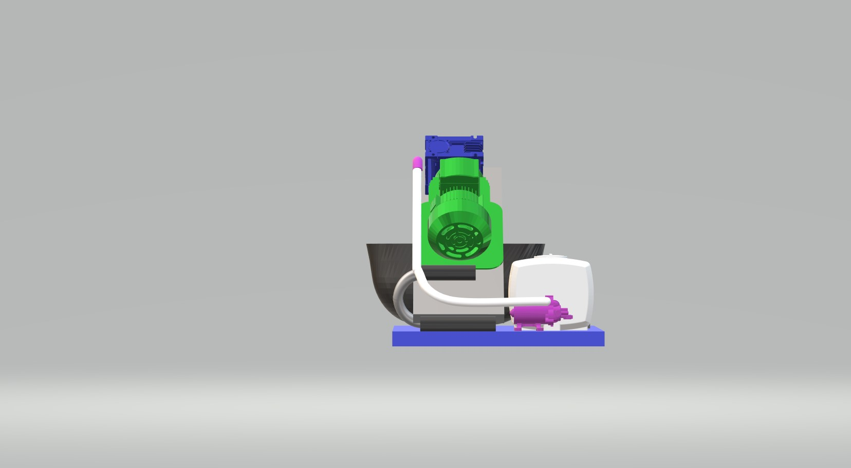

Side View
